# **Creating Docker hosted repository in Nexus and pushing the docker image through Jenkins**

## **Pre-requisite:**

* We need to have Jenkins and nexus server up and running (by default Jenkins runs on 8080 and nexus at 8081), to install on ubuntu refer [link](https://github.com/DeekshithSN/cheatsheet/blob/master/installtion_guide_ubuntu.md)
* On Jenkins host we need to install docker

## **Initial setup**

In nexus click on gear button --> click on repositories --> click on create repository ( below image can help in creating )

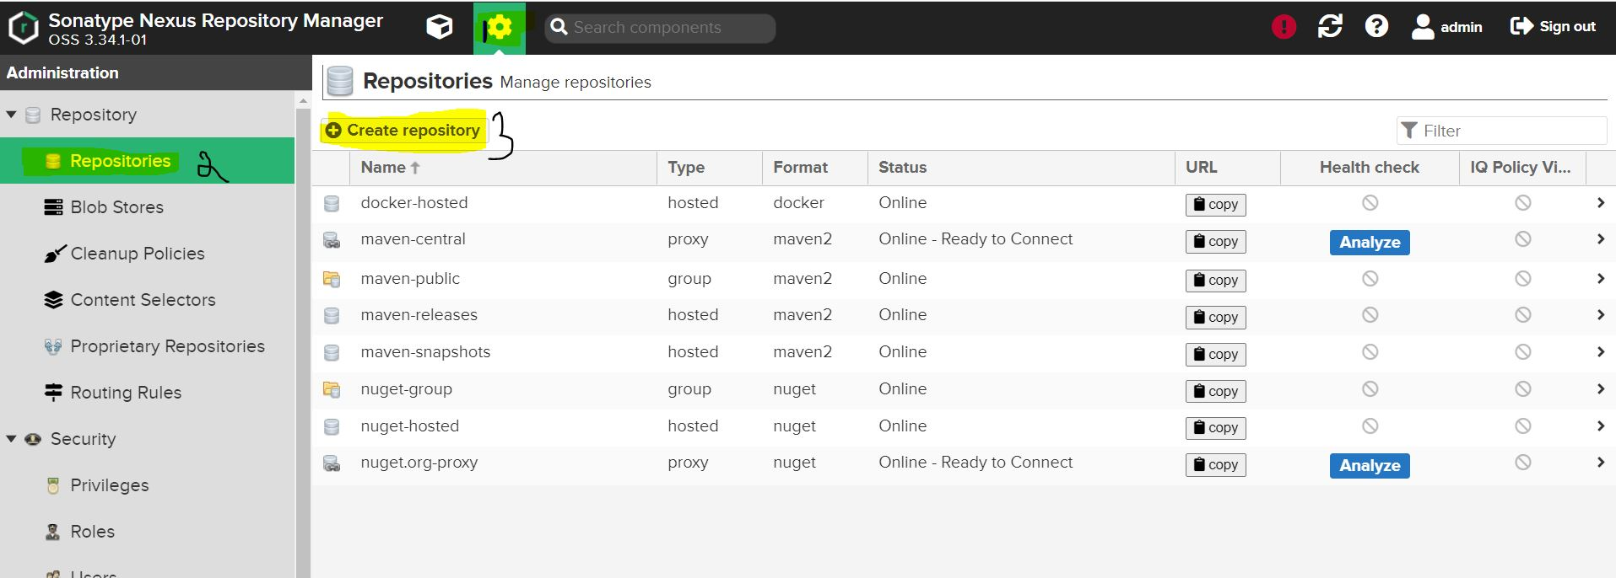

once we click on create repository ( types of repository will be listed ) --> click on docker(hosted)

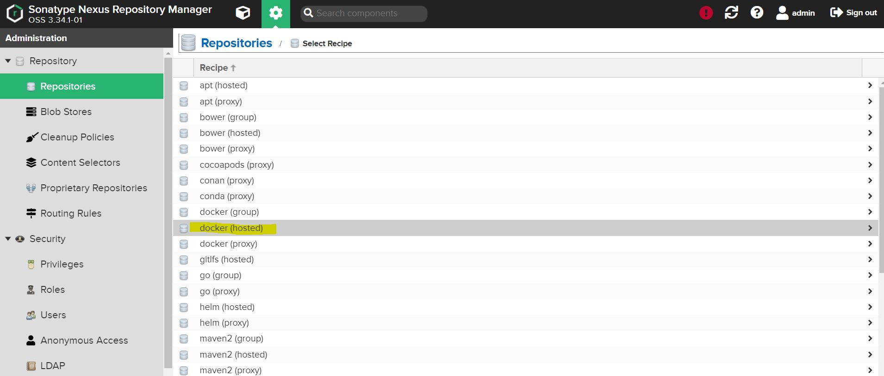

fill out the details in Name ( unique name ), enable checkbox beside to HTTP and enter a valid port ( preferred 8083 ) once that click on create repository

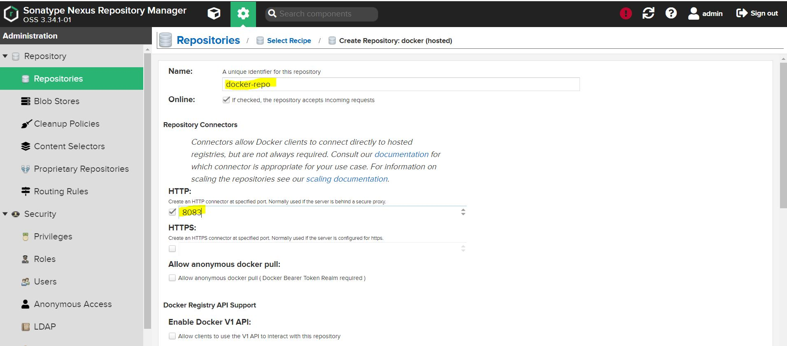 

Once this set up is done in jenkins host we need to setup Insecure Registries. to do that we need to edit or if not present create a file /etc/docker/daemon.json in that file add details of nexus

**{ "insecure-registries":["nexus_machine_ip:8083"] }**

once that's done we need to execute **systemctl restart docker** this is to apply new changes, also we can verify whether registry is added or not by executing docker info

once this is done from jenkins host you can try

**docker login -u nexus_username -p nexus_pass nexus_ip:8083**